Name: Kainaat Rafiq Hussain Makhani
Registration Number: 2012296
Semester and Section: 7A
Lab 08
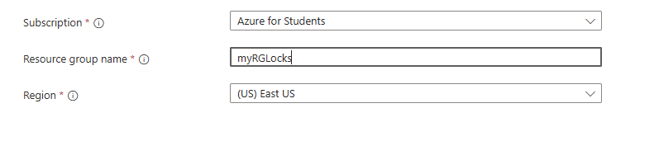

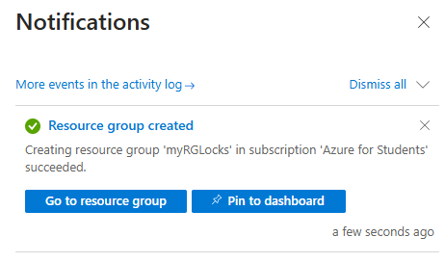

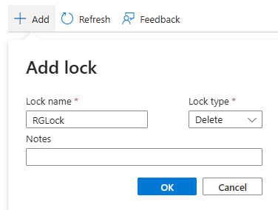

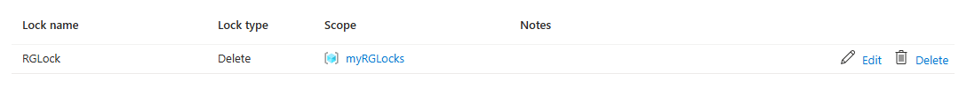

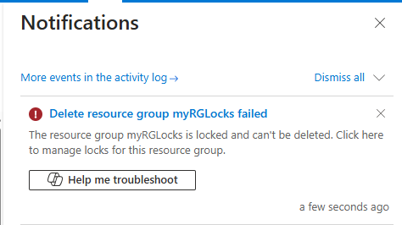

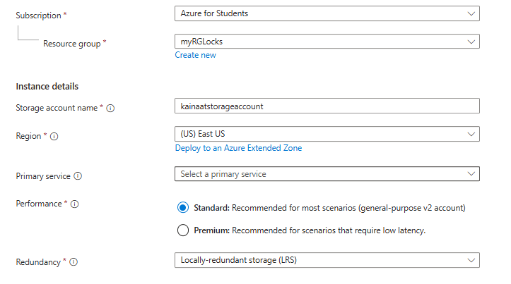

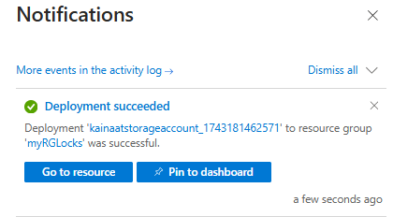

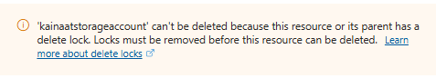

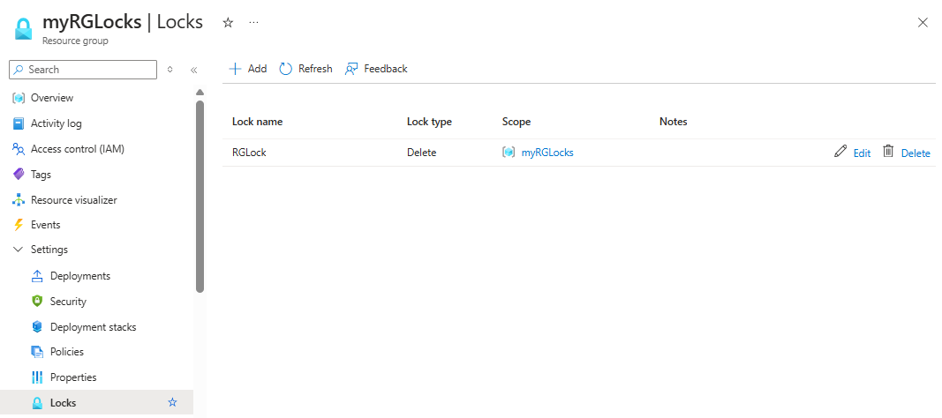

Description:
In this lab, we learned how to create and manage Azure resources using best practices. A resource group was created and protected using a Delete Lock to prevent accidental deletion. We explored built-in Azure policies related to security and performance, such as enforcing the latest TLS version and HTTP settings for App Services. A storage account was also deployed successfully. This lab helped us understand how to secure and manage resources efficiently in the Azure environment.

